**Courtyard Moonlight Orchid:**

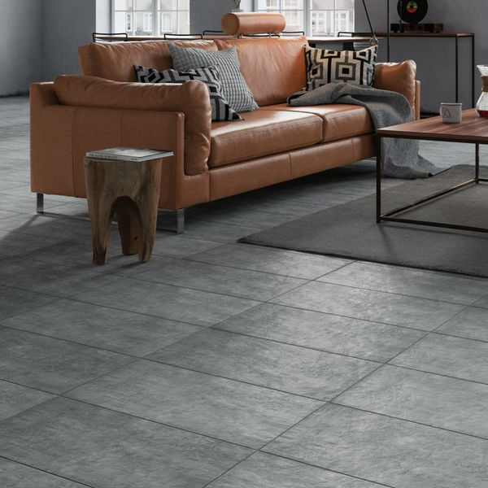

**Product Description**

Bring your home up to date with these stylish Moonlight Orchid Slate Effect Tiles. Grey in colour, they have a lifelike stone effect design, which is perfect for creating a natural scheme in your interior areas. These tiles are made from durable porcelain, so they can cater for both wall and floor areas! They have a matt finish. For the full effect, order a sample tile.

**What's special about these tiles?**

> Dark grey hue  
> Slate effect design  
> Natural matt finish  
> Durable porcelain construction

## **Product Info**

* Product ID: 24749
* Tiles Per SQM: 5.6304404130491
* Sale by: Per SQM
* Size: 297x598x8mm
* Weight: 3.55 KG
* Material Type: Porcelain
* Finish: Matt
* Colour: Grey
* Suitability: Floors, Walls
* Grade: 4
* Rectified Edge: No
* Underfloor Heating: Yes
* Anti Slip Grade: R10 / 27-35 Degrees
* Thickness (mm): 8